Zahid Mursleen
24F-0593

TASK 01

#include<iostream>
using namespace std;

int main()
{
double var1, var2;
cout << "Enter value of var1: ";
cin >> var1;
cout << "Enter value of var2: ";
cin >> var2;
double* ptrVar1 = &var1; // Assigned address of var1 to double pointer
double* ptrVar2 = &var2; // Assigned address of var2 to double pointer
cout << "var1 = " << *ptrVar1 << endl; //Derefrencing ptrVar1
cout << "var2 = " << *ptrVar2 << endl;//Derefrencing ptrVar2
}

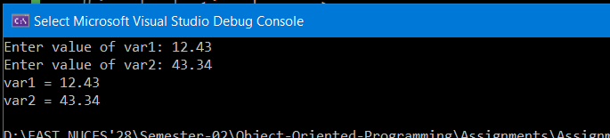

TASK 02

#include <iostream>
#include <cstring>
#include <conio.h>
using namespace std;

void GenerateCode(int* P1, int* P2, char* line);
void Decode(int* P1, int* P2, char* line);

int main()
{
string rollNo;
char line[50];
char ch;
cout << "Enter your roll no: ";
bool flag = false;

while (!flag)
{
rollNo.clear();
while ((ch = _getch()) != '\r')
{
cout << ch;
rollNo += ch;
if (ch == 'f' || ch == 'F' ||
ch == 'i' || ch == 'I' ||
ch == 'p' || ch == 'P' ||
ch == 'l' || ch == 'L' ||
ch == 'k' || ch == 'K') {
cout << '-';
rollNo += '-';
}
}
flag = true;
int leng = rollNo.length();
if (leng == 8)
break;
else {
cout << "\nInvalid rollno..." << endl;
cout << "Please enter correct rollNo: ";
flag = false;
}
}
cout << endl;

int a = (rollNo[4] - '0') + (rollNo[5] - '0') + 1; // For capital letters
int b = (rollNo[6] - '0') + (rollNo[7] - '0') + 1; // For small letters
int* P1 = &a;
int* P2 = &b;

cout << "Enter original line: ";
cin.getline(line, 50);

// Encode the line
GenerateCode(P1, P2, line);
cout << "Encoded line: " << line << endl;

// Decode the line
Decode(P1, P2, line);
cout << "Decoded line: " << line << endl;
return 0;
}

void GenerateCode(int* P1, int* P2, char* line)
{
for (int i = 0; i < strlen(line); ++i)
{
if (line[i] >= 'A' && line[i] <= 'Z')
{
int encoded = line[i] + *P1;
if (encoded > 'Z')
encoded = 'A' + (encoded - 'Z' - 1);
line[i] = encoded;
}
else if (line[i] >= 'a' && line[i] <= 'z')
{
int encoded = line[i] + *P2;
if (encoded > 'z')
encoded = 'a' + (encoded - 'z' - 1);
line[i] = encoded;
}
}
}

void Decode(int* P1, int* P2, char* line)
{
for (int i = 0; i < strlen(line); ++i)
{
if (line[i] >= 'A' && line[i] <= 'Z')
{
int decoded = line[i] - *P1;
if (decoded < 'A')
decoded = 'Z' - ('A' - decoded - 1);
line[i] = decoded;
}
else if (line[i] >= 'a' && line[i] <= 'z')
{
int decoded = line[i] - *P2;
if (decoded < 'a')
decoded = 'z' - ('a' - decoded - 1);
line[i] = decoded;
}
}
}

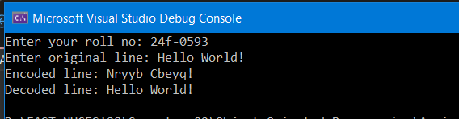

TASK 03

#include<iostream>
#include<cstring>
#include<conio.h>
using namespace std;

void menu();
int _strlen(const char* ch)
{
int leng = 0;
for (int i = 0; ch[i] != '\0'; ++i)
{
leng++;
}
return leng;
}
int _strcmp(const char* str1, const char* str2)
{
for (int i = 0; str1[i] != '\0' || str2[i] != '\0'; ++i)
{
if (str1[i] > str2[i])
return 1;
else if(str1[i] < str2[i])
return -1;
}
return 0;
}
int _strncmp(const char* str1, const char* str2, int n)
{
int str1Leng = _strlen(str1);
int str2Leng = _strlen(str2);
while(n > str1Leng || n > str2Leng)
{
cout << "n-can't be greater than string 1 or string 2"<< endl;
cout << "Enter number of characters to compare: ";
cin >> n;
}
for (int i = 0; i < n; ++i)
{
if (str1[i] > str2[i])
return 1;
else if (str1[i] < str2[i])
return -1;
}
return 0;
}
char* _strcpy(char* des, const char* src)
{
int leng = _strlen(src);
for (int i = 0; i < leng; ++i)
{
*(des + i) = *(src + i);
}
*(des + leng) = '\0';
return des;
}
char* _strncpy(char* des, const char* src, int n)
{
int leng = _strlen(src);
while (n > leng || n < 0)
{
cout << "n-can't be greater than string 1 or string 2" << endl;
cout << "Enter number of characters to compare: ";
cin >> n;
}
for (int i = 0; i < n; ++i)
{
*(des + i) = *(src + i);
}
*(des + n) = '\0';
return des;
}
char* _strcat(char* str1, const char* str2)
{
int leng1 = _strlen(str1);
int leng = _strlen(str2);
for (int i = 0; i < leng; ++i)
{
*(str1 + leng1 + i) = *(str2 + i);
}
*(str1 + leng + leng1) = '\0';
return str1;
}
char* _strncat(char* str1, const char* str2, int n)
{
int leng1 = _strlen(str1);
int leng = _strlen(str2);
while (n > leng || n < 0)
{
cout << "n-can't be greater than string 1 or string 2" << endl;
cout << "Enter number of characters to compare: ";
cin >> n;
}
for (int i = 0; i < n; ++i)
{
*(str1 + leng1 + i) = *(str2 + i);
}
*(str1 + n + leng1) = '\0';
return str1;
}

int main()
{
menu();
return 0;
}
void menu()
{
char str1[100];
char str2[100];
cout << "Select the desired choice " << endl;
cout << endl;
cout << "1. Find lenght of string:" << endl;
cout << "2. Compare two strings: "<< endl;
cout << "3. Compare parts of two strings"<< endl;
cout << "4. Copy one string to other"<< endl;
cout << "5. Copy part of a string" << endl;
cout << "6. Concatinate two string" << endl;
cout << "7. Concatinate one with part of other" << endl;
char ch1;
cout << "Enter your choice:";
cin >> ch1;
cin.ignore();
if (ch1 == '1')
{
cout << "Enter string:";
cin.getline(str1, 100);
int leng = _strlen(str1);
cout << "Lenght of string: " << leng;
_getch();
system("cls");
main();
}
else if (ch1 == '2')
{
cout << "Enter string-01: ";
cin.getline(str1, 100);
cout << "Enter string-02: ";
cin.getline(str2, 100);
int val = _strcmp(str1, str2);
if (val > 0)
cout << "String 1 is greater than string 2" << endl;
else if (val < 0)
cout << "String 1 is less than string 2" << endl;
else
cout << "Strings are equal :)" << endl;
_getch();
system("cls");
main();
}
else if (ch1 == '3')
{
int n;
cout << "Enter string-01: ";
cin.getline(str1, 100);
cout << "Enter string-02: ";
cin.getline(str2, 100);
cout << "Enter number of characters to compare: ";
cin >> n;
int val = _strncmp(str1, str2,n);
if (val > 0)
cout << "String 1 is greater than string 2" << endl;
else if (val < 0)
cout << "String 1 is less than string 2" << endl;
else
cout << "Strings are equal :)" << endl;
_getch();
system("cls");
main();
}
else if (ch1 == '4')
{
cout << "Enter strin: ";
cin.getline(str1, 100);
int leng = _strlen(str1);
char* cpyString = new char[leng + 1];
char* returnStr = _strcpy(cpyString, str1);
cout << "Copied string: " << returnStr << endl;
_getch();
system("cls");
main();
}
else if (ch1 == '5')
{
int n;
cout << "Enter string: ";
cin.getline(str1, 100);
cout << "Enter number of characters to copy:";
cin >> n;
int leng = _strlen(str1);
char* cpyString = new char[n + 1];
char* returnStr = _strncpy(cpyString, str1, n);
cout << "Copied string to n number of characters: " << returnStr << endl;
_getch();
system("cls");
main();
}
else if (ch1 == '6')
{
cout << "Enter string-01: ";
cin.getline(str1, 200);
int leng = _strlen(str1);
cout << "Enter string-02: ";
cin.getline(str2, 100);
char* str = _strcat(str1, str2);
cout << "Concated string :" << str;
_getch();
system("cls");
main();
}
else if (ch1 == '7')
{
int n;
cout << "Enter string-01: ";
cin.getline(str1, 200);
int leng = _strlen(str1);
cout << "Enter string-02: ";
cin.getline(str2, 100);
cout << "Enter number of characters you want to concat: ";
cin >> n;
char* str = _strncat(str1, str2, n);
cout << "Concated string :" << str;
_getch();
system("cls");
main();
}
}

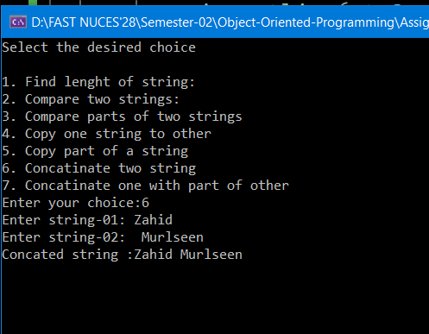

TASK 04

#include<iostream>
using namespace std;

float* addArrays(float* arr1, float* arr2,float* arr3, int size)
{
for (int i = 0; i < size; ++i)
{
*(arr3 + i) = *(arr1 + i) + *(arr2 + i);
}
return arr3;
}
int main()
{
float arr1[50] = { 0 }, arr2[50] = { 0 }, arr3[50] = { 0 };
cout << "Enter the size of array: ";
int size;
cin >> size;
for (int i = 0; i < size; ++i)
{
*(arr1 + i) = (rand() % 10 + 20) * 0.27;
*(arr2 + i) = (rand() % 10 + 30) * 0.37;
}
cout << "Array 1: ";
for (int i = 0; i < size; ++i)
{
cout << *(arr1 + i) << " ";
}
cout << endl;
cout << "Array 2: ";
for (int i = 0; i < size; ++i)
{
cout << *(arr2 + i) << " ";
}
cout << endl;
float* result = addArrays(arr1, arr2, arr3, size);
cout << "Resultant array: ";
for (int i = 0; i < size; ++i)
{
cout << *(result + i) << " ";
}
}

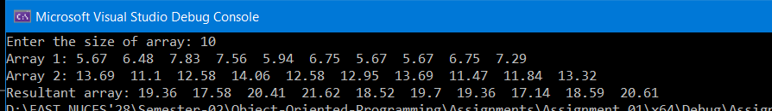

TASK 06

#include<iostream>
#include<Windows.h>
#include<ctime>
using namespace std;

void initiTrack(char*);
void display(char*);
void moveTortoise(char*, int*);
void moveHare(char*, int*);
bool condChecking(int*pos1,int* pos2, char* ch);
int main()
{
int tortoisePos = 1;
int harePos = 1;
int* posPtr = &tortoisePos;
int* posPtr1 = &harePos;
char track[80];
initiTrack(track);
bool flag = true;
while (flag)
{
moveTortoise(track, posPtr);
moveHare(track, posPtr1);
display(track);
bool val = condChecking(posPtr, posPtr1, track);
if (!val)
{
flag = false;
continue;
}
system("cls");
}
return 0;
}

//Initializing Track
void initiTrack(char* track)
{
track[0] = 'T';
track[1] = 'H';
for (int i = 0; i < 80; ++i)
{
track[i] = ' ';
}
}

//Displaying Track
void display(char* track)
{
for (int i = 1; i < 80; ++i)
{
cout << track[i];
}
Sleep(1000);
}

// Tortoise position
void moveTortoise(char* track, int* pos)
{
track[*pos] = ' ';
*pos = rand() % 50 + 1;
if (*pos >= 1 && *pos <= 25)
{
*pos += 4; //fast plod
if (*pos > 80)
*pos = 80;
}
else if (*pos >= 26 && *pos <= 35)
{
*pos -= 5; // slip
if (*pos < 1)
{
*pos = 1;
}
}
else if (*pos >= 36 && *pos <= 50)
{
*pos += 1; //slow plod
if (*pos > 80)
*pos = 80;
}
track[*pos] = 'T';

}

//Hare position
void moveHare(char* track, int* pos)
{
track[*pos] = ' ';
*pos = rand() % 50 + 1;
if (*pos <= 19)
{
*pos = *pos; //Sleep
if (*pos > 80)
*pos = 80;
}
else if (*pos <= 29)
{
*pos += 11; // Big hop
if (*pos > 80)
*pos = 80;
}
else if (*pos <= 39)
{
*pos -= 9; //slow plod
if (*pos < 1)
*pos = 1;
}
else
*pos += 1;

track[*pos] = 'H';
}
bool condChecking(int* pos1, int* pos2, char* track)
{
if (*pos1 == *pos2 && *pos1 <= 80 && *pos2 <= 80) {
int start;
if (*pos1 > *pos2)
start = *pos1 - 2;
else
start = *pos2 - 2;
const char* ouch = "OUCH!!!";
for (int i = 0; i < 7; i++) {
if (start + i < 80) {
track[start + i] = ouch[i];
}
else {
break;
}
}
}
if (*pos1 >= 80 || *pos2 >= 80)
{
if (*pos1 >= 80 && *pos2 >= 80)
{
cout << "\n\nIt's a tie.\n";
}
else if (*pos1 >= 80)
{
cout << "\n\nTORTOISE WINS!!! YAY!!!\n";
}
else
{
cout << "\n\nHare wins. Yuck.\n";
}
return false;
}
return true;
}

